实验编号：3 **四川师大Android高级开发实验报告 2020**年 **3**月 **27**日

**计算机科学学院** 级 3 班 实验名称： 多牌游戏

姓名： 吴文娇 学号： 2017110543 指导老师： 樊相奎 实验成绩:_____

**实验 三 多牌游戏**

1. 实验目的及要求

目的：

(1) 完善游戏逻辑;

(2) 采用布局完善界面;

(3) Activity 引入游戏逻辑实现可玩的多纸牌游戏。

要求：

(1) 认真填写实验报告，要求附加部分运行界面和主要代码;

(2) 对设计好的程序，检查输出是否符合预期，如有错请分析错误原因并解决;

1. 实验内容

(1) M:在实验 2 的基础上，新建游戏逻辑类;

a) 实现纸牌两张牌匹配功能;

b) 可翻牌，可积分;

(2) V:引入布局修改界面，实现多牌布局，要求布局规整;

(3) C:控制器代码 Activity 做适当调整;

1. 实验主要流程、基本操作或核心代码、算法片段（该部分如不够填写，请另加附页）

***游戏逻辑类：CardMatchingGame.Java***

**package** com.example.fairy.myapplication.model;  
**import** java.util.ArrayList;**public class** CardMatchingGame {  
 **private** ArrayList<Card> **cards**;  
  
 **private int count** = 0;  
 **private int score** = 0;  
  
 **public** CardMatchingGame(**int** count) {*//构造12张牌* **this**.**count** = count;  
 Deck deck = **new** PlayingDeck();  
 **cards** = **new** ArrayList<Card>();  
 **for** (**int** i = 0; i < count; i++) {  
 Card card = deck.drawRandomCard();  
 **if** (card != **null**) {  
 **cards**.add(card);  
 }  
 }  
 }  
  
 **public void** reset() {  
 Deck deck = **new** PlayingDeck();  
 **cards** = **new** ArrayList<Card>();  
 **for** (**int** i = 0; i < **count**; i++) {  
 Card card = deck.drawRandomCard();  
 **if** (card != **null**) {  
 **cards**.add(card);  
 }  
 }  
 }  
  
 **public** Card cardAtIndex(**int** index) {*//随记找牌* **return** (index < **cards**.size()) ? **cards**.get(index) : **null**;  
 }  
  
 **public int** getScore() {  
 **return score**;  
 }  
  
 **public int** count() {  
 **return count**;  
 }  
  
 **final int MISMATCH_PENALTY** = 2;  
 **final int MATCH_BONUS** = 4;  
 **final int COST_TO_CHOOSE** = 1;  
  
 **public void** chooseCardAtIndex(**int** index) {  
 *//游戏逻辑* Card card = cardAtIndex(index); *//1张牌* **if** (!card.isMatched()) { *//match为真表示牌被选过了* **if** (card.isChosen()){ *//chosen表示正反面* card.setChosen(**false**);  
 } **else** {  
 **for** (Card otherCard : **cards**) {  
 **if** (otherCard.isChosen() && !otherCard.isMatched()) {  
 **int** matchScore = card.match(**new** Card[]{otherCard});  
 **if** (matchScore > 0) {  
 **score** += matchScore * **MATCH_BONUS**;  
 otherCard.setMatched(**true**);  
 card.setMatched(**true**);  
 } **else** {  
 **score** -= **MISMATCH_PENALTY**;  
 otherCard.setChosen(**false**);  
 }  
 **break**;  
 }  
 }  
 **score** -= **COST_TO_CHOOSE**;  
 card.setChosen(**true**);  
 }  
 }  
 }  
  
}

***activity_main.xml***

*<?***xml version="1.0" encoding="utf-8"***?>*<**android.support.constraint.ConstraintLayout xmlns:android="http://schemas.android.com/apk/res/android"  
 xmlns:app="http://schemas.android.com/apk/res-auto"  
 xmlns:tools="http://schemas.android.com/tools"  
 android:layout_width="match_parent"  
 android:layout_height="match_parent"  
 android:background="#006f00"  
 tools:context="edu.sicnu.r.thecard.MainActivity"**>  
  
  
 <**GridView  
 android:id="@+id/gridView"  
 android:layout_width="368dp"  
 android:layout_height="427dp"  
 android:numColumns="4"** />  
  
 <**LinearLayout  
 android:id="@+id/LinearLayout"  
 android:layout_width="368dp"  
 android:layout_height="60dp"  
 android:orientation="horizontal"  
  
 app:layout_constraintBottom_toBottomOf="parent"  
 app:layout_constraintEnd_toStartOf="parent"  
 app:layout_constraintStart_toStartOf="parent"  
 app:layout_constraintTop_toBottomOf="@+id/gridView"**>  
  
 <**TextView  
 android:id="@+id/TextView_Score"  
 android:layout_width="105dp"  
 android:layout_height="wrap_content"  
 android:ems="10"  
 android:inputType="textPersonName"  
 android:text="Score:0"  
 tools:layout_editor_absoluteX="16dp"  
 tools:layout_editor_absoluteY="449dp"** />  
  
 <**Button  
 android:id="@+id/button"  
 android:layout_width="wrap_content"  
 android:layout_height="wrap_content"  
 android:text="Reset"  
 tools:layout_editor_absoluteX="261dp"  
 tools:layout_editor_absoluteY="447dp"** />  
  
 </**LinearLayout**>  
</**android.support.constraint.ConstraintLayout**>

***card_layout.xml***

*<?***xml version="1.0" encoding="utf-8"***?>*<**LinearLayout xmlns:android="http://schemas.android.com/apk/res/android"  
 android:layout_width="wrap_content"  
 android:layout_height="wrap_content"  
 android:background="#00df81"**>  
  
 <**Button  
 android:id="@+id/Button_Card"  
 android:layout_width="wrap_content"  
 android:layout_height="145dp"  
 android:layout_weight="1"  
 android:text="Button"** />  
</**LinearLayout**>

***MainActivity.java***

**package** edu.sicnu.r.thecard;  
  
**import** android.media.AudioManager;  
**import** android.media.SoundPool;  
**import** android.support.v7.app.AppCompatActivity;  
**import** android.os.Bundle;  
**import** android.view.LayoutInflater;  
**import** android.view.View;  
**import** android.view.ViewGroup;  
**import** android.widget.BaseAdapter;  
**import** android.widget.Button;  
**import** android.widget.GridView;  
**import** android.widget.TextView;  
**import** android.widget.Toast;  
  
**import** edu.sicnu.r.thecard.Model.Card;  
**import** edu.sicnu.r.thecard.Model.CardMatchingGame;  
**import** edu.sicnu.r.thecard.Model.PlayingDeck;  
  
**public class** MainActivity **extends** AppCompatActivity {  
 **int count** = 0;  
 SoundPool **sp** = **new** SoundPool(5, AudioManager.***STREAM_MUSIC***, 0);  
 **int soundID**;  
  
 Button **button**;  
 CardMatchingGame **game**;  
 GameAdapter **gameAdapter**;  
 TextView **TextView_Score**;  
  
 @Override  
 **protected void** onCreate(Bundle savedInstanceState) {  
 **super**.onCreate(savedInstanceState);  
 setContentView(R.layout.***activity_main***);  
 **soundID** = **sp**.load(**this**, R.raw.***meow***, 0);  
 **TextView_Score** = findViewById(R.id.***TextView_Score***);  
 **button** = findViewById(R.id.***button***);  
  
 GridView gridView = findViewById(R.id.***gridView***);  
 **game** = **new** CardMatchingGame(12);  
 **gameAdapter** = **new** GameAdapter(**this**,**game**);  
 gridView.setAdapter(**gameAdapter**);  
  
 **button**.setOnClickListener(**new** View.OnClickListener(){  
 **public void** onClick(View view){  
 **game**.reset();  
 updateUI();  
 **TextView_Score**.setText(**"Score:"**+0);  
 }  
 });  
  
 }  
  
  
 **public void** updateUI(){  
 **sp**.play(**soundID**,1.0f,1.0f,0,0,1.0f);  
 **gameAdapter**.notifyDataSetChanged();  
 **TextView_Score**.setText(**"Score:"**+**game**.getScore());  
 }  
 **static class** GameAdapter **extends** BaseAdapter{  
 MainActivity **context**;  
 CardMatchingGame **game**;  
 GameAdapter(MainActivity context,CardMatchingGame game){  
 **this**.**game** = game;  
 **this**.**context** = context;  
 }  
 @Override  
 **public int** getCount() {  
 **return game**.count();  
 }  
  
 @Override  
 **public** Object getItem(**int** i) {  
 **return game**.cardAtIndex(i);  
 }  
  
 @Override  
 **public long** getItemId(**int** i) {  
 **return** 1;  
 }  
  
 @Override  
 **public** View getView(**final int** i, View view, ViewGroup viewGroup) {  
 Button cardButton;  
 **if**(view == **null**){  
 View v = LayoutInflater.*from*(**context**).inflate(R.layout.***card_layout***,**null**);  
 cardButton = v.findViewById(R.id.***Button_Card***);  
 }**else**{  
 cardButton = (Button) view;  
 }  
 Card card = **game**.cardAtIndex(i);  
  
 **if**(card.isChosen()) {  
 cardButton.setBackgroundResource(R.drawable.***blankcard***);  
 cardButton.setText(card.getContents());  
 }**else**{  
 cardButton.setBackgroundResource(R.drawable.***stanfordtree***);  
 cardButton.setText(**""**);  
 }  
  
 **if** (card.isMatched()){  
 cardButton.setAlpha((**float**)0.7);  
 }  
 cardButton.setOnClickListener(**new** View.OnClickListener(){  
 @Override  
 **public void** onClick(View view){  
 **game**.chooseCardAtIndex(i);  
 **context**.updateUI();  
 }  
 });  
 **return** cardButton;  
 }  
 }  
}

1. 实验结果的分析与评价（该部分如不够填写，请另加附页）

1.初始化

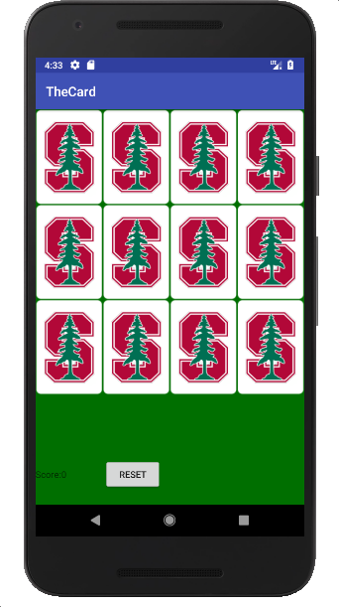

2.第一轮游戏

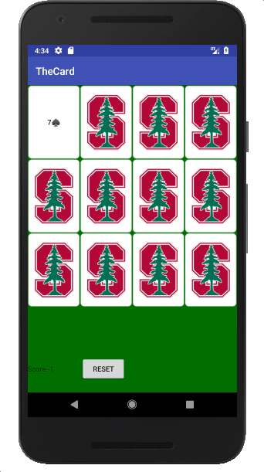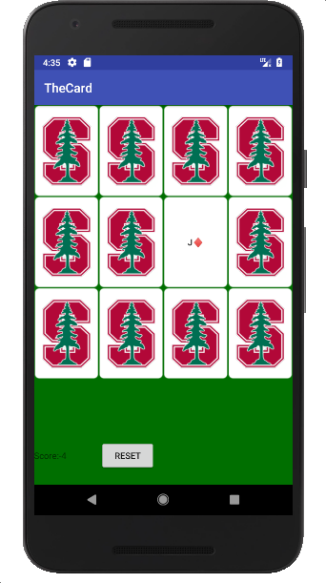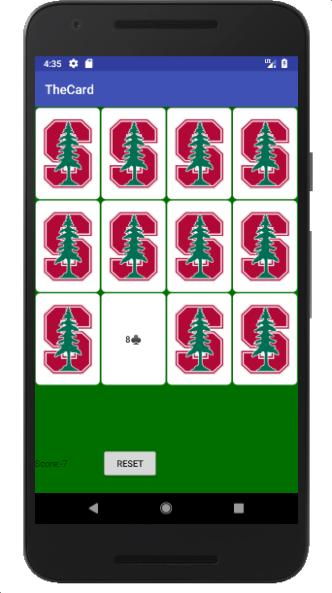

3.reset



4.第二轮游戏

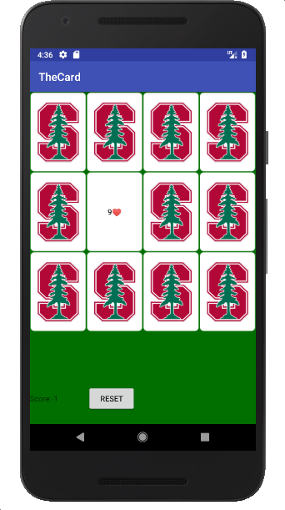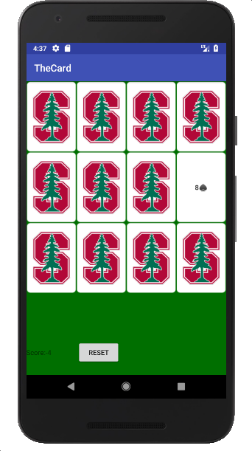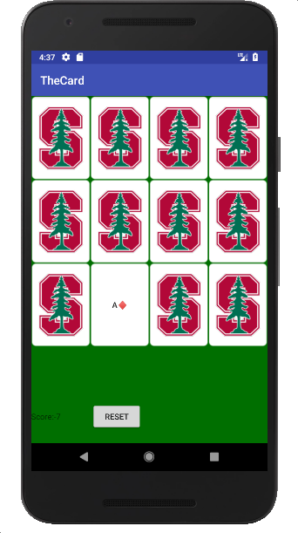

注：实验成绩等级分为（90－100分）优，（80－89分）良，(70-79分)中，（60－69分）及格，（59分）不及格。